
GOVERNOR STIRLING SENIOR HIGH SCHOOL

SEMESTER 1 EXAMINATION, 2015

QUESTION/ANSWER BOOKLET

HUMAN BIOLOGY ATAR
YEAR 11

NAME:

Time allowed for this paper
Reading time before commencing work: ten minutes
Working time for paper: three hours

Materials required/recommended for this paper

To be provided by the supervisor

This Question/Answer Booklet
Multiple-choice Answer Sheet

To be provided by the candidate

Standard items: pens, pencils, eraser, correction fluid, ruler, highlighters
Special items: non-programmable calculators satisfying the conditions set by the School Curriculum and Standards Authority for this course

Important note to candidates
No other items may be taken into the examination room. It is your responsibility to ensure that you do not have any unauthorized notes or other items of a non-personal nature in the examination room. If you have any unauthorized material with you, hand it to the supervisor before reading any further.
Structure of this paper

Section | Number of questions available | Number of questions to be answered | Suggested working time  (minutes) | Marks available | Percentage of exam
Section One:  Multiple-choice | 30 | 30 | 40 | 30 | 30
Section Two:  Short answer | 8 | 8 | 90 | 100 | 50
Section Three:  Extended answer | 4 | 2 | 50 | 40 | 20
 |  |  |  |  | 100

Instructions to candidates

1. The rules for the conduct of this exam are outlined in information to candidates for all examinations at Governor Stirling Senior High School. Sitting this examination implies that you agree to abide by these rules.

2. Answer the questions according to the following instructions.

Section One: Answer all questions on the separate Multiple-choice Answer Sheet provided. For each question shade the box to indicate your answer. Use only a blue or black pen to shade the boxes. If you make a mistake, place a cross through that square, do not erase or use correction fluid, and shade your new answer. Marks will not be deducted for incorrect answers. No marks will be given if more than one answer is completed for any question.

Sections Two and Three: Write your answers in this Question/Answer Booklet.

3. You must be careful to confine your responses to the specific questions asked and to follow any instructions that are specific to a particular question.

4. Spare pages are included at the end of this booklet. They can be used for planning your responses and/or as additional space if required to continue an answer.
  - Planning: If you use the spare pages for planning, indicate this clearly at the top of the page.
  - Continuing an answer: If you need to use the space to continue an answer, indicate in the original answer space where the answer is continued, i.e. give the page number. Fill in the number of the question that you are continuing to answer at the top of the page.
Section One: Multiple-choice 30% (60 Marks)

This section has 30 questions. Answer all questions on the separate Multiple-choice Answer Sheet provided. For each question shade the box to indicate your answer. Use only a blue or black pen to shade the boxes. If you make a mistake, place a cross through that square, do not erase or use correction fluid, and shade your new answer. Marks will not be deducted for incorrect answers. No marks will be given if more than one answer is completed for any question.

Suggested working time for this section is 40 minutes.

- Which of the following statements concerning cell membranes is true?

(a) Water passes freely through a cell membrane.
(b) A substance that is soluble in lipids will be repelled by a cell membrane.
(c) The size of a substance will not affect whether it passes through a cell membrane.
(d) Cell membranes allow all substances to pass through freely.

Question 2 refers to the diagram shown below.

The diagram below represents an experiment carried out in a school laboratory. A semi permeable membrane separates two solutions. The membrane is only permeable to substances small enough to fit through the pores.
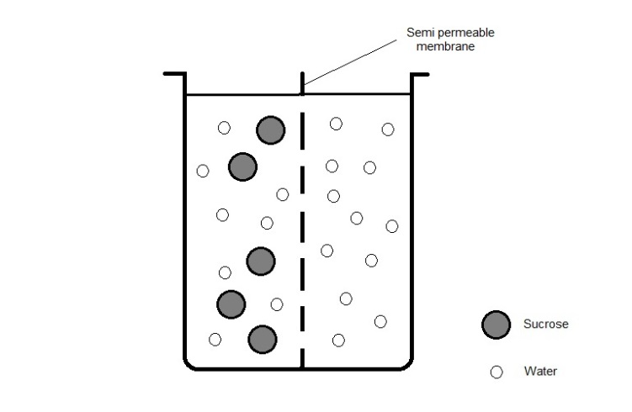
Semi permeable
membrane
Sucrose
Water
Side A
Side B

- Which of the following statements is true?

(a) Osmosis will favour the movement of water molecules from side B to side A.
(b) There will be no net movement of water molecules.
(c) Sucrose molecules will readily diffuse from side A to side B.
(d) There will be no change in the volume of solution on either side of the membrane.

- There is an upper limit on the size of a cell. Cells rarely grow much larger than microscopic size. The explanation for this is that as a cell grows, its surface area to volume ratio

(a) decreases, causing it to lose heat too easily.
(b) increases, affecting its metabolism.
(c) increases, making it difficult to retain cell requirements.
(d) decreases, making it difficult to obtain cell requirements.
- The shaft of a long bone is called the

  - periosteum
  - trabeculae
  - epiphysis
  - diaphysis.

- Emulsification of fat

(a) is a form of mechanical digestion.
(b) is brought about by pancreatic lipase.
(c) requires an acidic environment.
(d) is a form of chemical digestion.

- When glucose is broken down into carbon dioxide and water, most of the energy is

(a) used in cellular respiration.
(b) used for cell growth and division.
(c) released as heat to maintain body temperature.
(d) needed for the movement of cellular organelles and cell maintenance.

- Consider the table below, which indicates the parts of the digestive tract where chemical digestion of various foods occurs. An X indicates a positive result.

Section of Digestive Tract | Food 1 | Food 2 | Food 3 | Food 4
Mouth | X
Stomach |  | X
Small intestine | X | X | X

Which food is most likely to be a piece of meat?

(a) Food 1
(b) Food 2
(c) Food 3
(d) Food 4

- An athlete with a high count of red blood cells will perform well in tests of physical endurance because

(a) waste products will be removed from the body easily.
(b) excess levels of glucose will increase levels of respiration.
(c) the reduced plasma volume will lower carbon dioxide levels.
(d) high levels of oxygen will be available to the muscles

- Compared to inhaled air, exhaled air should contain a higher percentage of

(a) oxygen, carbon dioxide and water vapour.
(b) nitrogen, carbon dioxide and oxygen.
(c) carbon dioxide and nitrogen.
(d) carbon dioxide and water vapour.

Questions 10 – 11 refer to the diagram below, which shows the components of the blood.

- Which of the following statements is correct?

(a) A contains haemoglobin
(b) B carries oxygen around the body
(c) C is part of the immune system
(d) D is mainly made of proteins

- Which component transports about 75% of the carbon dioxide around the body?

(a) A.
(b) B.
(c) C.
(d) D.

- During vigorous activity a knee ligament is damaged and the knee joint becomes destabilised. An undamaged ligament acts to

- secrete synovial fluid
- form a capsule around a joint
- join bone to bone
- join muscle to bone.

- The composition of urine involves:

  - Water, Urea, Glucose, Creatinine.
  - Sodium Chloride, Hormones, Glucose, Water.
  - Water, Uric acid, Sodium ions, Urea.
  - Proteins, Uric acid, Glucose, Water.

Questions 14 and 15 refer to the following graph.

The graph shows results from an experiment testing the effect of exercise on weight loss.

Weight loss (kg)

With 30 minutes exercise a day

With no exercise

Time (weeks)

- A logical hypothesis for the investigation could have been:

(a) A younger person will lose weight faster than an older person.
(b) Moderate physical activity will reduce body weight.
(c) If no exercise is undertaken a person can still consistently lose weight.
(d) Fitness can be altered with daily exercise.

- The line on the graph showing ‘with no exercise’ is a representation of

(a) another investigation’s results.
(b) results from a repeat trial.
(c) the independent variable results.
(d) the control group results.

- The human skeleton

i) surrounds delicate organs, thus offering them a degree of protection.
ii) is hard due to the deposition of the minerals calcium and phosphorous.
iii) allows the attachment of smooth muscles for movement across joints.

Which of the statements above are CORRECT?

  - i), ii) and iii).
  - i) and ii) only.
  - ii) and iii) only.
  - i) and iii) only.

- Proteins are made up of units called

  - amino acids
  - peptide bonds
  - glucose
  - monosaccharides
Question 18 refers to the diagram shown below:

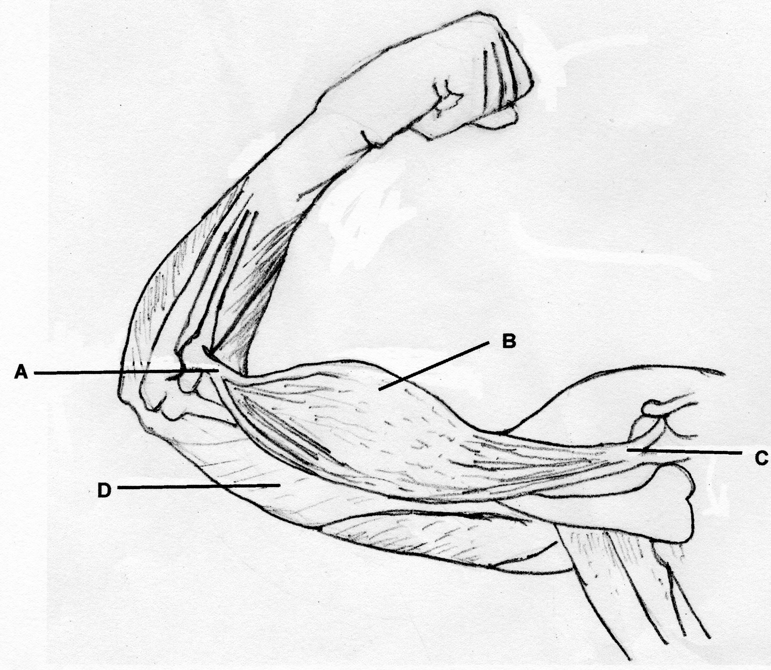

- In the diagram

  - A and C represent the origin and insertion while B and D represent the agonist and antagonist respectively
  - A and C represent the origin and insertion while B and D represent the antagonist and the agonist respectively
  - A and C represent the insertion and origin while B and D represent the antagonist and the agonist respectively
  - A and C represent the insertion and origin while B and D represent the agonist and the antagonist respectively.

- Which of the following lists has an anabolic process followed by a catabolic process?

 | Anabolic process | Catabolic process
(a) | Respiration | Protein synthesis
(b) | Protein synthesis | Fat digestion
(c) | Anaerobic respiration | DNA replication
(d) | Anaerobic respiration | Aerobic respiration

- In a cell the reactions of aerobic respiration occur in the

  - cytoplasm and release ADP
  - mitochondria and release carbon dioxide, water and ATP
  - cytoplasm and release 36 molecules of ATP
  - mitochondria and require 36 molecules of ATP.

Questions 21and 22 refer to the following information:

As part of a study of human physiology, a scientist used an exercise bicycle and while controlling all other variables, tested a human subject to determine how heart beat changes during exercise and recovery. The data are given in the table below.

In Test A, the subject pedalled at 240 revolutions per minute. He could not continue after 8 minutes and stopped, feeling totally exhausted.

In Test B, after resting for an hour, the same subject then pedalled the cycle at 100 revolutions per minute until he was stopped after 20 minutes, despite feeling able to continue.

TEST A [240 cycles/min] |  |  | TEST B [100 cycles/min]
 | Time [minutes] | Heart rate  [beats per minute] |  | Time [minutes] | Heart rate  [beats per minute]
At rest | 0 | 78 | At rest | 0 | 78
Cycling | 2 | 150 | Cycling | 2 | 146
Cycling | 4 | 164 | Cycling | 4 | 158
Cycling | 6 | 174 | Cycling | 6 | 162
Cycling | 8 | 178 | Cycling | 8 | 164
Recovery | 10 | 180 | Cycling | 10 | 165
Recovery | 12 | 176 | Cycling | 12 | 168
Recovery | 14 | 172 | Cycling | 14 | 172
Recovery | 16 | 168 | Cycling | 16 | 174
Recovery | 18 | 162 | Cycling | 18 | 176
Recovery | 20 | 156 | Cycling | 20 | 176
Recovery | 22 | 150 | Recovery | 22 | 120
Recovery | 24 | 142 | Recovery | 24 | 104
Recovery | 26 | 134 | Recovery | 26 | 100
Recovery | 28 | 124 | Recovery | 28 | 96
Recovery | 30 | 102 | Recovery | 30 | 93
Recovery | 32 | 80 | Recovery | 32 | 85
Recovery | 34 | 78 | Recovery | 34 | 78
Recovery | 36 | 78 | Recovery | 36 | 78

- In terms of chemical reactions taking place within the subject’s muscle cells, the most accurate explanation for not being able to continue beyond 8 minutes in Test A while he was able to continue cycling for 20 minutes in Test B is
  - In Test A the subject relied on anaerobic respiration for energy.
  - In Test B the subject relied on anaerobic respiration for energy.
  - In Test B the subject relied on the partial breakdown of glucose.
  - In Test A the subject relied on the complete breakdown of glucose.

- In the experiment which of the following would improve the reliability of results?
i Measure heart rate more accurately.
ii Increase the number of subjects from one to ten.
iii Repeat the experiment ten times.
iv Measure body temperature as well as heart rate.

  - i only
  - i, ii and iii only
  - ii and iii only
  - i, ii, iii and iv
- Lungs are positioned deep in the body to

- Protect from sporting injuries.
- Prevent excessive evaporation of fluids.
- Prevent blood loss.
- Enable the ribs to touch them.

- When a human is exposed to changes in the composition of the normal gaseous environment, the breathing rate alters. The following results were obtained after testing a randomly-sampled group of 100 students:

Composition of air | Average breaths/minute
 | 1st | 2nd | 3rd | 4th | 5th
100% O₂ | 16 | 15 | 13 | 11 | 9
90% O_{2,} 10% CO₂ | 16 | 17 | 19 | 23 | 28
20% O_{2.} 0.08% CO_{2,} 80% N₂ | 16 | 15 | 15 | 16 | 15

A satisfactory conclusion drawn from these results would be

- pure O₂ will not support life
- increases in O₂ above 20% causes increase in breathing rate
- increases in CO₂ content causes increase in breathing rate
- nitrogen concentration has little effect on breathing rate

- An obstruction in the glomerulus in a nephron would block the flow of blood into the

  - renal artery.
  - efferent arteriole.
  - glomerular capsule.
  - afferent arteriole.

- Which of the following is NOT a function of the Circulatory System?

- It is involved in the transportation of dissolved nutrients.
- It forms part of the immune system.
- It acts to regulate body temperature.
- It produces amino acids for use as protein in muscle tissue.
Question 27 refers to the diagram representing a cell in a salt solution as shown below

- Which one of the following statements is correct?
  - This cell will gain water while there is no nett movement of salt.
  - This cell will lose both salt and water to the external environment.
  - Salt will move into the cell and water will move out of the cell.
  - Water and salt will move into the cell’s cytoplasm.
- The table below presents data obtained by measuring the concentration of a variety of substances in the brain tissue of elderly patients.

 | Extracellular (mg/L)  (outside cells) | Intracellular (mg/L)  (inside cells)
Sodium | 137 | 10
Potassium | 5 | 141
Calcium | 5 | 2
Chloride | 103 | 44
Sulfate | 15 | 25
Glucose | 90 | 20

Which of the following statements is correct?

- Glucose will diffuse into the cells
- Chloride will diffuse out of the cells
- Potassium will diffuse into the cells
- Sulphate will diffuse into the cells
Questions 29 and 30 refer to the diagram of the heart below.
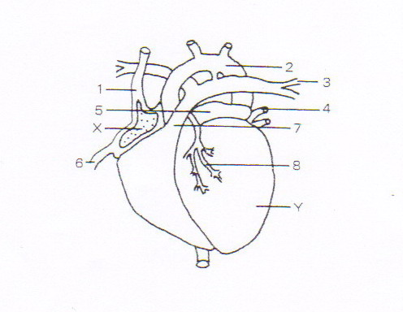
- Which blood vessels supply oxygenated blood to the cardiac muscle?

  - 1.
  - 8.
  - 4.
  - 2.
- Which blood vessel/s carries/carry oxygenated blood?
- 2 only
- 3 and 4
- 3 only
- 2 and 4

End of Section One
Section Two: Short answer 50% (100 Marks)

This section has eight (8) questions. Answer all questions. Write your answers in the space provided.

Spare pages are included at the end of this booklet. They can be used for planning your responses and/or as additional space if required to continue an answer.
  - Planning: If you use the spare pages for planning, indicate this clearly at the top of the page.
  - Continuing an answer: If you need to use the space to continue an answer, indicate in the original answer space where the answer is continued, i.e. give the page number. Fill in the number of the question(s) that you are continuing to answer at the top of the page.

Suggested working time for this section is 90 minutes.

Question 31 (11 marks)
The following question refers to the diagram of the long bone shown below

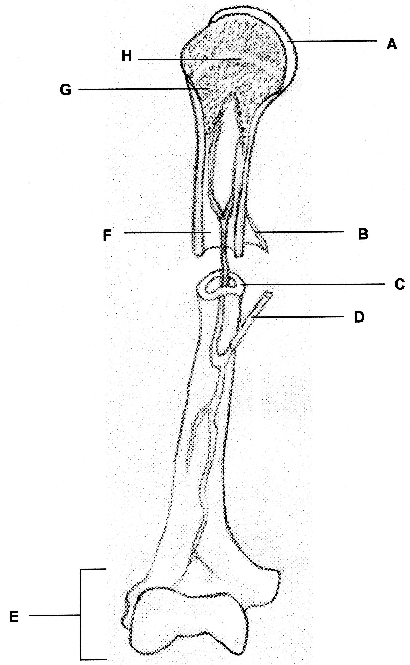

(a) Label the following parts (2 marks)
B ____________________________________________________________________
C ____________________________________________________________________
E ____________________________________________________________________
H ____________________________________________________________________

(b) Give the name and function of the following parts (2 marks)

A ______________________________________________________________________
______________________________________________________________________
D ______________________________________________________________________
______________________________________________________________________

(c) What does F contain? (1 mark)

______________________________________________________________________

(d) What type of bone makes up structure G? (1 mark)

(e) The diagram below represents the sliding filament model of muscle contraction. A sarcomere in a skeletal muscle is shown in the relaxed position.

(i) Identify the proteins labelled as A and B in the diagram (1 mark)

A

B

(ii) In the box below, accurately redraw the same sarcomere as it would appear when the muscle is contracted. (2 marks)

(iii) Explain what has happened to cause the change you have shown in the diagram between the relaxed and contracted positions of the sarcomere. (2 marks)

Question 32 (14 marks)

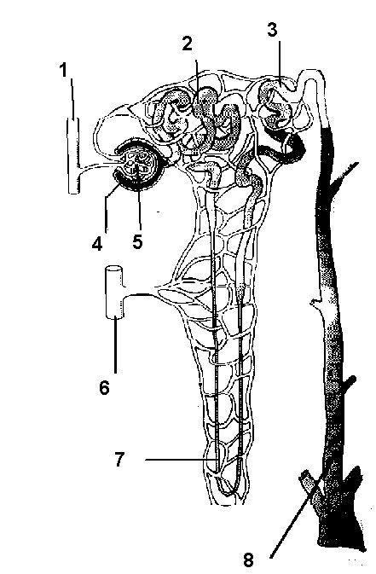
http://www.rcs.rome.ga.us/hargett/anatomy/urine/nephron.htm

- Identify the parts of the nephron in the table below. (3 marks)

Number on diagram | Structure
2
4
7

- Name a structure of the nephron that is responsible for each of the following functions:

- Filtration (1 mark)

________________________________________________________________________

- Selective reabsorption (1 mark)

________________________________________________________________________

- Facultative reabsorption (1 mark)

___________________________________________________________________________

- Describe TWO ways in which the structure of the nephron is related to its function.
(2 marks)

________________________________________________________________________

________________________________________________________________________

________________________________________________________________________

________________________________________________________________________

- Which of the following substances would you NOT expect to find in the urine of a non-diseased person? Circle your answer/s. (1 mark)

water urea creatinine glucose amino acids

- Explain your answer. (2 marks)

________________________________________________________________________

________________________________________________________________________

________________________________________________________________________

- Which of the following substances would you NOT expect to find in the filtrate of a non-diseased person? Circle your answer/s. (1 mark)

urea red blood cells plasma proteins creatinine amino acids

- Explain your answer. (2 marks)

________________________________________________________________________

________________________________________________________________________

________________________________________________________________________

Question 33 (14 marks)

(a) Chemical reactions in the body can be classed as catabolic or anabolic. Describe the difference between these two types of reactions. (2 marks)

(b) Explain how enzymes can speed up chemical reactions. (2 marks)

(c) In the space below, draw a labelled diagram showing the three stages of enzyme action in the lock and key model. (6 marks)

(d) Describe and explain how the following factors can affect enzyme activity.

(i) Temperature (2 marks)

- pH (2 marks)

Question 34 (17 marks)

(a) How does the chemical composition of the blood in the aorta differ from that of the blood in the right and left pulmonary arteries?

__________________________________________________________________

__________________________________________________________________

__________________________________________________________________

__________________________________________________________________
(1 mark)

The cardiac cycle involves the contraction and relaxation of the heart. Changes in blood pressure reflect this cycle in the body

(b) Complete the following table by stating whether the atria and ventricles are contracted or relaxed in each of the three cardiac phases.

Phase of Cardiac Cycle | Atria | Ventricles
Atrial Systole

Ventricular Systole

Atrial and Ventricular
Diastole

(3 marks)
(c) Describe the roles of the atrioventricular valves during the cardiac cycle.

___________________________________________________________________________________________________________________________________________________________________________________________________________________________________________________________________________________________________________________________________________________________________________________________
(2 marks)

The following table shows the results of an experiment carried out to determine blood flow in arterioles of various diameters.

Diameter of Arteriole (micrometres) | Rate of blood flow (ml per second)
5 | 1
8 | 3
15 | 5
30 | 20
40 | 40

(d) Graph the results from the table on the grid provided below. (5 marks)

If you wish to have a second attempt at the graph, the grid is repeated on page 38 at the end of this Question/Answer Booklet. Indicate clearly on this page if you have used the second grid and cancel the working on the grid on this page.

(e) Using the graph, what is the expected rate of blood flow in an arteriole with a diameter of 35 micrometres?

__________________________________________________________________
(1 mark)

(f) What is an arteriole?

__________________________________________________________________

(1 mark)

(g) Fill in the table below. The differences between arteries and veins are:

ARTERIES | VEINS
(4 marks)

Question 35 (10 marks)

Alana, Chloe and Mikaela carried out an experiment to investigate the effect of temperature on the action of the enzyme sucrase.

Each student set up eight test tubes. Each test tube was kept at a different temperature. The time taken for the sucrose to completely breakdown was recorded and the results from some of the test tubes were averaged.

The results of the experiment are in the table below:

Test tube | Temperature  (ºC) | Time taken for sucrose to completely breakdown (Minutes)
Test tube | Temperature  (ºC) | Alana | Chloe | Mikaela | Average
1 | 0 | 49 | 53 | 51 | 51.0
2 | 10 | 15 | 14 | 16
3 | 20 | 10 | 6 | 9
4 | 30 | 4 | 5 | 4 | 4.3
5 | 40 | 4 | 7 | 6 | 5.7
6 | 50 | 26 | 30 | 28
7 | 60 | 90 | 140 | 100 | 110
8 | 70 | 110 | 115 | 110

(a) Complete the table for the incomplete test tube averages. (2 marks)
(b) State an hypothesis that this experiment has been designed to test.

__________________________________________________________________ __________________________________________________________________ __________________________________________________________________
(2 marks)

(c) (i) State the independent variable.

_________________________________________________________________
(1 mark)
(ii) State the dependent variable.

__________________________________________________________________
(1 mark)

(d) Identify four variables that the students should have controlled during this experiment.

Controlled Variable

1-

2-

3-

4-

(2 marks)

(e) Do the results obtained support the proposed hypothesis? Explain.

__________________________________________________________________ __________________________________________________________________ __________________________________________________________________ __________________________________________________________________ __________________________________________________________________
(2 marks)

Question 36 (14 marks)

  - Below is a diagram of the human digestive system. Name the parts labelled A, B, C and D and outline their main function.
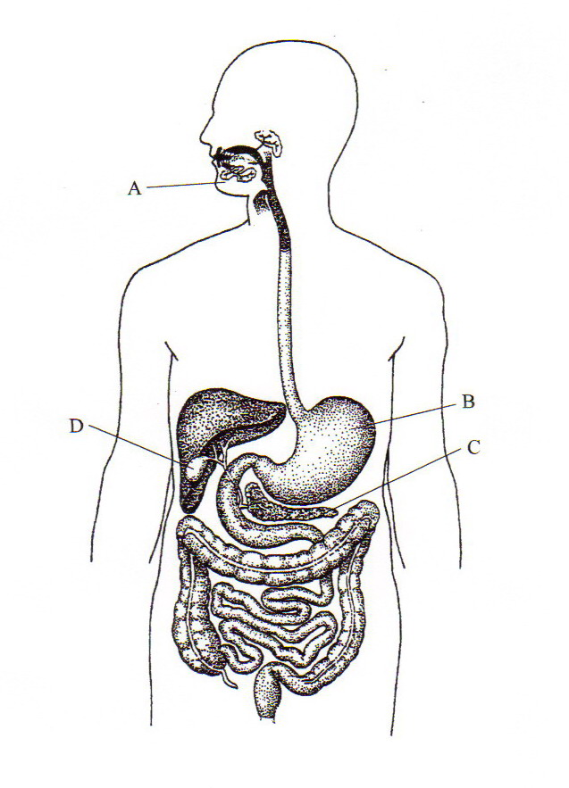

 | NAME | FUNCTION
A
B
C
D
(6 marks)
  - State the sources of the digestive enzyme amylase. Describe the specific role of amylase in the digestion process. (3 marks)

(e) Peristalsis is a form of mechanical digestion. (5 marks)

(i) In the space provided, name one (1) other example of mechanical digestion.

(ii) In the table, contrast these two processes in terms of where they occur (ii) and the function of the process (iii).

 | Peristalsis | (i)
(ii)
Where it occurs

(iii)
Function

Question 37 (12 marks)

The diagram below shows the Structure of the Respiratory System

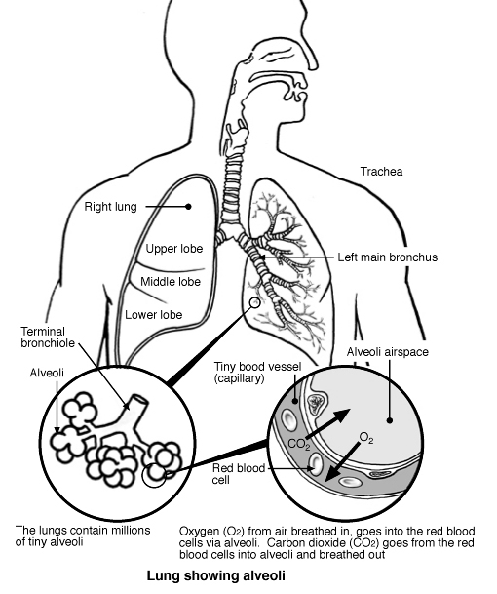
[Adapted from: Patient UK, n.d.]

2

1
(a) Name features 1 and 2 and explain how they are suited to the function they perform.
(4 marks)

1

2

Use the following information to answer Question 36 (b).

Research has shown that smoking cigarettes will result in the following physiological damage to the respiratory system:

Effect 1 Destruction of many of the cilia that line parts of the respiratory system

Effect 2 The walls of the alveoli rupturing.

Effect 3 The thickening of the walls of the bronchioles therefore narrowing their diameter.

(b) For each of the effects listed above, describe how smoking interferes with the normal functioning of the respiratory system.

Effect | Description
1
2
3
(3 marks)

(c) Explain how the process of inspiration occurs. (5 marks)

Question 38 (8 marks)

Cells use a range of structures and processes to regulate their metabolism and interact with their environment.

(a) Give one reasons why all organisms need each of the following

i) nucleus ___________________________________________________________
____________________________________________________________________

ii) ribosomes _________________________________________________________
____________________________________________________________________
(2 marks)

(b) ATP is an important molecule for energy flow in living organisms. List four uses for energy in cells.
____________________________________________________________________
____________________________________________________________________
____________________________________________________________________ ____________________________________________________________________
(2 marks)

c) Although humans need oxygen to survive, some people eg sprint swimmers and pearl divers appear to be able to go without taking a breath for some time

(i) Name the metabolic process for obtaining energy from the breakdown of organic compounds in the absence of oxygen.

__________________________________________________________

(ii) Compare the amount of ATP produced from one molecule of glucose in the presence and absence of oxygen.

__________________________________________________________

(iii) Name the end products from the breakdown of glucose in the presence of oxygen in humans.

__________________________________________________________

(iv) Name the end products from the breakdown of glucose in the absence of oxygen in a human

__________________________________________________________

(4 marks)

End of Section Two
Section Three: Extended answer 20% (40 Marks)

This section contains four (4) questions. You must answer two (2) questions. Write your answers in the space provided.

Spare pages are included at the end of this booklet. They can be used for planning your responses and/or as additional space if required to continue an answer.
  - Planning: If you use the spare pages for planning, indicate this clearly at the top of the page.
  - Continuing an answer: If you need to use the space to continue an answer, indicate in the original answer space where the answer is continued, i.e. give the page number. Fill in the number of the question(s) that you are continuing to answer at the top of the page.

Responses may include clearly labelled diagrams with explanatory notes; lists of points with linking sentences; clearly labelled tables and graphs; and annotated flow diagrams with introductory notes.

Suggested working time for this section is 50 minutes.

Question 39 (20 marks)

- Cells experience a constant exchange of materials with their environment. Identify two (2) methods by which cells transport materials across their membranes. Describe these two methods and explain the factors that affect their action. (6 marks)

- Structures in the respiratory, digestive and excretory systems require large surface areas to accomplish their particular functions. Choose one structure from each system and explain how a large surface area is obtained and why the large surface area is needed. (10 marks)

- Explain why cells are so small in size? (4 marks)

Question 40 (20 marks)

- The digestive system carries out six (6) basic processes. List these processes.
(3 marks)

- Describe all of the processes that would occur in the digestive system when a person eats a meal consisting of a ham sandwich which contains starch, protein and fat. In your answer include (where applicable): (17 marks)

Type of process
The sites of each process
The enzymes involved and their source
Substrates
Products
How each substance enters the blood

Question 41 (20 marks)

Cellular Respiration is one of the most important metabolic processes that take place in the cell.

- Describe how the energy released by this process is stored in the cell and then released for use in the cell. (3 marks)

- Compare and contrast the processes of aerobic and anaerobic respiration. (8 marks)

- There are three processes that are involved with the formation of urine in the kidneys. Describe these processes. Include in your answer the substances involved in each process and location in the kidney tubules for each. (9 marks)

Question 42 (20 marks)

(a) Outline the pathway taken by a red blood cell through the heart. Start at the point where blood returns to the heart via the vena cava and finish where blood leaves the heart via the aorta. Include in your answer the events that occur along the pathway.
(12 marks)

(b) There are three major types of joints in the human body. Name and describe these both structurally and functionally. Give an example of where each type is found in the human body.
(8 marks)

END OF QUESTIONS

Additional working space

Additional working space

Use the grid to answer question 34(d) if you have cancelled your first attempt.

